FrameSet (Nested FrameSet)

# Program 1:

<!DOCTYPE html>

<html lang="en">

<head>

    <meta charset="UTF-8">

    <meta name="viewport" content="width=device-width, initial-scale=1.0">

    <title>Document</title>

</head>

<frameset cols="33.33%,33.33%,33.33%">

    <frame src="../frame_components/cnt2 copy.html">

    <frame src="../frame_components/cnt3.html">

    <frame src="../frame_components/cnt4.html">

</frameset>

</html>

# OutPut :

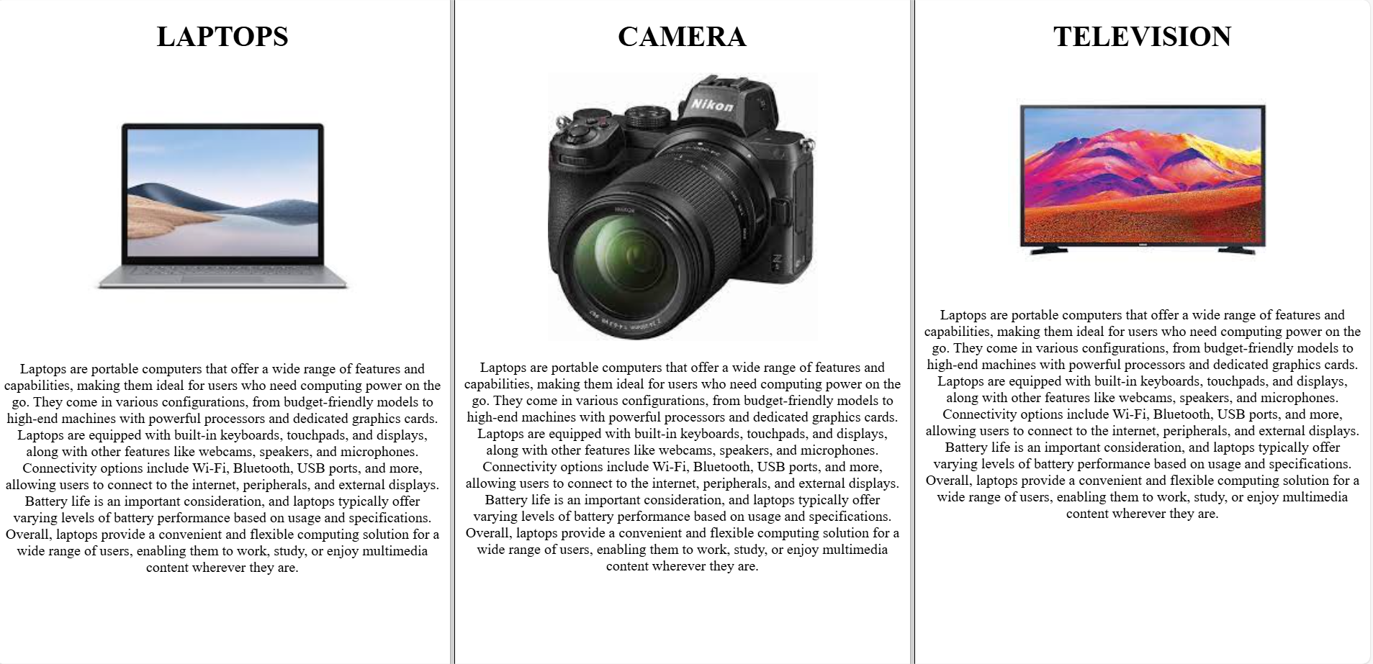

# Program 2 :

<!DOCTYPE html>

<html lang="en">

<head>

    <meta charset="UTF-8">

    <meta name="viewport" content="width=device-width, initial-scale=1.0">

    <title>Document</title>

</head>

<frameset rows="33.33%,33.33%,33.33%">

    <frame src="../frame_components/cnt_angular.html">

    <frame src="../frame_components/cnt_java.html">

    <frame src="../frame_components/cnt_php.html">

</frameset>

</html>

# OutPut :

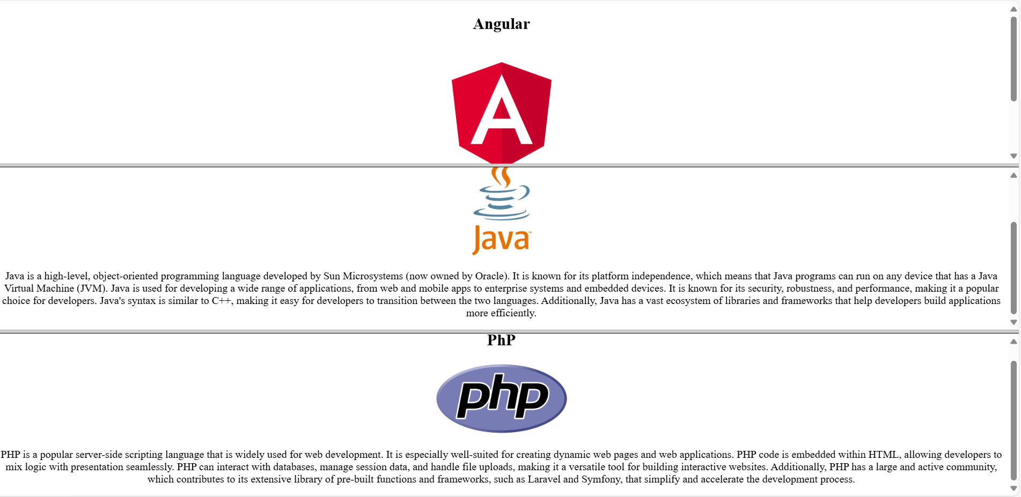

# Program 3 :

<!DOCTYPE html>

<html lang="en">

<head>

       <title>Document</title>

</head>

<frameset cols="30%,70%">

    <frame src="../frame_components/cnt1.html">

    <frameset rows="33.33%,33.33%,33.3%">

        <frameset cols="50%,50%">

            <frame src="../frame_components/cnt_angular.html">

            <frame src="../frame_components/cnt_java.html">

        </frameset>

        <frame src="../frame_components/cnt2.html">

        <frameset cols="50%,50%">

            <frame src="../frame_components/cnt_php.html">

            <frame src="../frame_components/cnt_dart.html">

        </frameset>

    </frameset>

</frameset>

</html>

# OutPut :

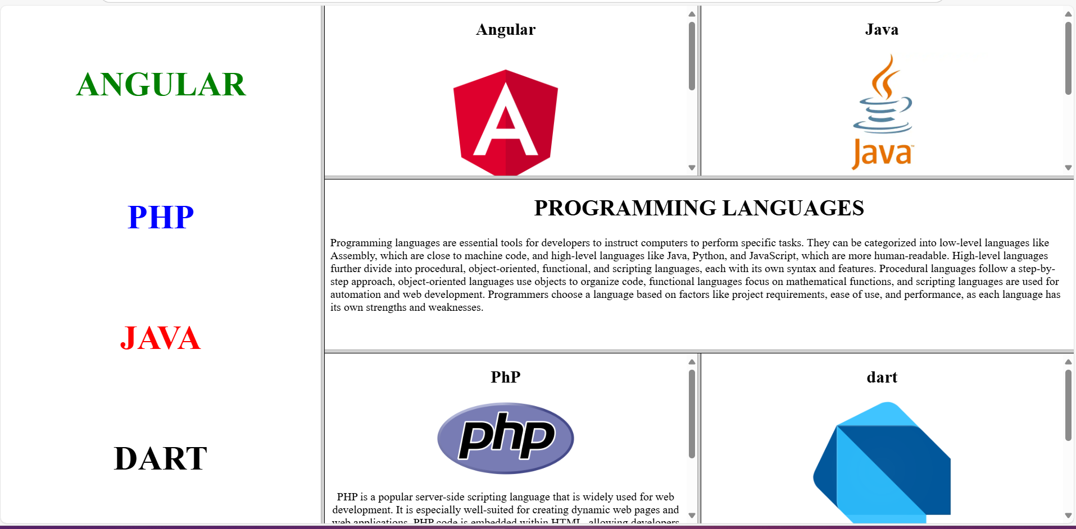

# Program 4 :

<!DOCTYPE html>

<html lang="en">

<head>

    <meta charset="UTF-8">

    <meta name="viewport" content="width=device-width, initial-scale=1.0">

    <title>Document</title>

</head>

<frameset rows="20%,80%">

    <frame src="../frame_components/laptop.html">

    <frameset cols="50%, 50%">

        <frame src="../frame_components/cnt2 copy.html">

        <frameset rows="33.33%, 33.33%,33.33%">

            <frame src="../frame_components/laptop_data1.html">

            <frame src="../frame_components/laptop_data2.html">

            <frame src="../frame_components/laptop_data3.html">

        </frameset>

    </frameset>

</frameset>

</html>

# OutPut :



# Program 5:

<!DOCTYPE html>

<html lang="en">

<head>

    <meta charset="UTF-8">

    <meta name="viewport" content="width=device-width, initial-scale=1.0">

    <title>Document</title>

</head>

<frameset rows="25%, 25%, 50%">

    <frame src="../frame_components/main_heading.html">

    <frame src="../frame_components/sub_heading.html">

    <frameset cols="30%, 70%">

        <frame src="../frame_components/laptopimg.html">

        <frameset rows="33.33% , 33.33% , 33.33%">

            <frame src="../frame_components/laptop_data1.html">

            <frame src="../frame_components/laptop_data2.html">

            <frame src="../frame_components/laptop_data3.html">

        </frameset>

    </frameset>

</frameset>

</html>

# OutPut :

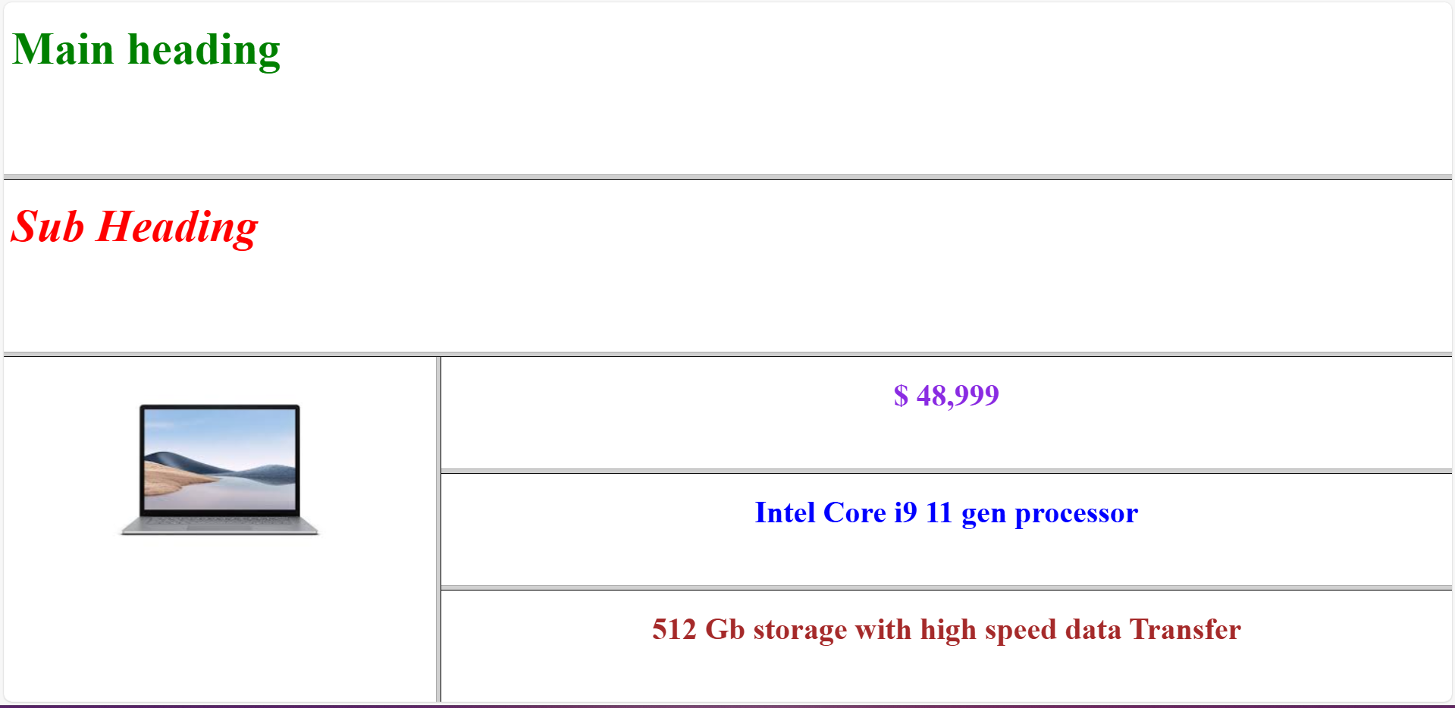

# Program 6 :

<!DOCTYPE html>

<html lang="en">

<head>

    <meta charset="UTF-8">

    <meta name="viewport" content="width=device-width, initial-scale=1.0">

    <title>Frames</title>

</head>

    <frameset cols="30%,70%">

        <frame src="../frame_components/cnt1.html" name="page1">

            <frameset rows="50%,50%">

                <frame src="../frame_components/cnt2.html" name="right-top">

                <frameset cols="33.33%,33.33%,33.33%">

                    <frame src="../frame_components/cnt_angular.html" name="angular">

                    <frame src="../frame_components/cnt_java.html" name="php">

                    <frame src="../frame_components/cnt_php.html" name="java">

                </frameset>

            </frameset>

    </frameset>

</html>

# OutPut :

